|  |  |
| --- | --- |
| Functional Specification : RT Dashboard Phase 2 | **Apple** |

Table of Contents

1. Requirements 2

2. BHU Report 3

3. Hyperlinks: 5

4. Interfaces 8

# Requirements

1. BHU Report
2. Interfaces
3. RT PLC Milestone
4. RT PLC Notification

# BHU Report

**Purpose:**

* BHU Report data to be displayed to users with the detailed information of the BHU from RT Standpoint
* By default BHU list should be pulled from ALM for the current quarter.
* Filter functionality for getting the BHU list based on the Apple Manger, BHU ID, RT PLC Milestones

**Process flow:**

* Under Reports page, additional menu item for “BHU Report” in the main page of the RT dashboard.
* On click of “BHU Report” link, report page should be loaded
* On load of Report page, BHU’s list from HP ALM should be displayed in Tabular form
* By default, Report data should be pulled based on Current Quarter in descending order.
* Quarter of a BHU can be pulled based on the ‘Target Cycle & Target Release’ fields from BHU Requirement in ALM.

**Field Details and mapping:**

|  |  |  |
| --- | --- | --- |
| **Label Name** | **Source of data** | **Field name in ALM** |
| BHU /IHU # | From Details tab of BHU Requirement in ALM | BHU ID |
| CURRENT STATUS | Should be arrived from the phase dates  From Details tab of BHU Requirement in ALM | Design review start date  Design review end date  Go live date  IT Start date  IT End date  UAT Start date  UAT End date  Planned RT Start date  Planned RT end date |
| SIZE | From Details tab of BHU Requirement in ALM | Sizing |
| IMPACTED OBJECTS | iEval | SAP Programs tab (Objects will be updated in Dev phase ) |
| PROJECT MANAGER | new field in ALM | Project Manager |
| RT SPOC | From Details tab of BHU Requirement in ALM | SPOC |
| RT EXTENDED TEAM MEMBERS | new field in ALM | Extended team members |
| SCRIPTS SHARED | From Project handover tab of BHU Requirement in ALM | No.of.Scripts Shared during IT Phase |
| SCRIPTS UTLISED | From Project handover tab of BHU Requirement in ALM | New (Name to be changed as ‘Scripts utilized by Project team’) |
| SCRIPTS EXECUTED | Test set in Test lab | No of scripts executed for the ticket  Test set name = RT Ticket # |
| RT DEFECTS | Defects tab | Project |
| RT MISS | ALM | BHU ID , Root cause |
| WARRANTY ISSUES | See Hyperlinks Part | ‘Name’ in Project warranty folder |
| SCRIPTS EXECUTED PART OF WARRANTY | Test Runs | Test Runs |
| NEW SCRIPTS RECEIVED | BHU Requirement in ALM | No.of.Scripts received( Label name to be modified as “ No.of.Scripts received (P2S)”) |
| SCRIPTS MODIFIED | From Project handover tab of BHU Requirement in ALM | Modify (Label name to be modified as “No of Scripts modified(P2S)”) |
| EFFOTRTS | RITM* ticket from central station (Should be visible only to internal RT team members) | Central station |

**Screen Settings:**

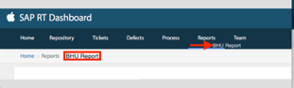

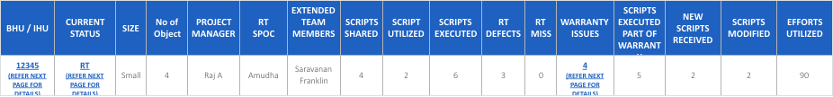

# Hyperlinks:

* There are 3 fields to be hyperlink enabled in the BHU report.
* On the click of the hyperlink, required information should be displayed in a POP UP.
* All the Pop Ups should have download option, so that the user can download the information to the presentation server.

a.**BHU/IHU # (Hyperlink)**

The BHU / IHU number should be an hyperlink. New Page / Pop up to be displayed on the click of the hyperlink with the below details.

* List of BHUs associated with the particular BHU
* BHU Description
* RT SPOC
* RT Ticket #

|  |  |  |
| --- | --- | --- |
| **Label Name** | **Source of Date** | **Field name in ALM** |
| BHU /IHU # | From Details tab of BHU Requirement in ALM | BHU ID |
| BHU DESCRIPTION | Should be retrieved from the Description field of the ALM requirement. Only First line should be fetched in the Description text. | Description |
| RT SPOC | From Details tab of BHU Requirement in ALM | SPOC |
| RT TICKET # | BHU Requirement Name in ALM | Name |

Screen :

|  |  |  |  |
| --- | --- | --- | --- |
| **BHU/IHU #** | **BHU DESCRIPTION** | **RT SPOC** | **RT TICKET #** |
| 14568 | *BHU Description* | Nithya | RITM00054792 |

b.**Current Status (Hyperlink)**

The current status of the BHU to be given as a hyperlink. New Page / Pop up to be displayed on the click of the hyperlink with the below details.

* BHU / IHU #
* RT PLC MILESTONE
* DATE
* RT SPOC
* MINUTES OF MEETING

This report will be covered under the second requirement (Interface 2). When this hyperlink is clicked, it should take the user to the output of the Interface 2. (Source for interface 2 will be covered in the later part of this document).

**Pop up Screen:**

|  |  |  |  |  |
| --- | --- | --- | --- | --- |
| **BHU / IHU #** | **RT PLC MILESTONE** | **DATE** | **RT SPOC** | **MINUTES OF MEETING** |
| BHU / IHU# | Design Review | 18/08/2017 | Nithya | Script sharing |
| BHU / IHU# | RT Scripts Sharing | 25/08/2017 | Nithya | Script Walkthrough |
| BHU / IHU# | IT Review | 15/09/2017 | Nithya | System Demo |

**Sample Pop up screen existing in RT Dashboard:**

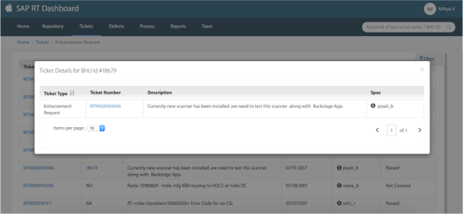

c.Warranty Issues (Hyperlink)

Number of warranty issues pertaining to the BHU to be given as a hyperlink. All the requirements where BHU ID = BHU # ,under the Project warranty folder for the pertaining quarter should be fetched. New Page / Pop up to be displayed on the click of the hyperlink with the below details. Following column Headers should be displayed in the Pop up

* TICKET #
* ROOT CAUSE
* JUSTIFICATION

|  |  |  |
| --- | --- | --- |
| **Label Name** | **Source of Data** | **Field Name in ALM** |
| TICKET # | From Project warranty requirement from ALM | Name |
| ROOT CAUSE | From Project warranty requirement from ALM | Root Cause |
| JUSTIFICATION | From comments field of the Project warranty requirement from ALM | Comments |

Pop up Screen:

|  |  |  |
| --- | --- | --- |
| **TICKET #** | **ROOT CAUSE** | **JUSTIFICATION** |
| RITM003240546 | New requirement | Not given as a part of the BRD |

**Filter / Search Functionality**

Filter Option should be available on right side to get the BHUs list based on their current Phase, Year and Quarter.

1. Drop down values for the filter “Phase” :

* Kick off (Source from BHU Req in ALM)
* Design / Dev
* IT
* UAT
* RT
* Warranty Phase
* P2S Handover

1. Select Year
2. Select Quarter(Q1/Q2/Q3/Q4)
3. Select Month

* Search based on BHU ID, Project Manager, SPOC
* Search using Project Manager and SPOC then Year, Quarter and Month filter should be enabled

Existing Filter sample in the RT Dashboard:

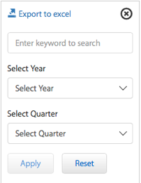

# Interfaces

**Interface 1:“RT PLC MILESTONE”**

**Purpose:**

* The purpose of this interface is to record the RT SPOC’s communication with the Project SPOC.
* Using this Interface RT SPOC should be able save the interaction/minutes of the meeting he/she had for the PLC Milestone.

**Process flow:**

* RT SPOC should be able to input the fields listed below.
* While clicking on the SAVE button, Minutes of the meeting should be appended in the HP ALM under Description field.
* Data from this interface will be utilized in the BHU Report (Requirement 1) when the user click on the CURRENT STATUS hyperlink.

**Field Details and mapping:**

|  |  |  |
| --- | --- | --- |
| **Label Name** | **Field type** | **Purpose** |
| DATE | Alphanumeric Text filed | Input field |
| BHU / IHU # | Alphanumeric Text filed | Input field |
| RT SPOC | Text field | Input field |
| RT PLC MILESTONE | Drop down list | Input field |
| ELUCIDATION/MOM | Text field | Input field |
| EFFORTS | Time Capture | Input field |
| SAVE | Button | On click of the Button entry should be saved in the DB. |
| RESET | Button | On click of the Button filled details should be cleared. |
| CANCEL | Button | On click of the Button action should be cancelled and control should take you to the home page. |

**Screen :**

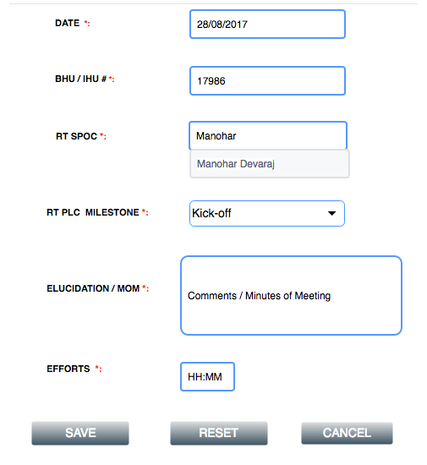

**Interface 2: “RT PLC NOTIFICATION”**

**Purpose:**

* New Interface to send email communication to the project team SPOC for the RT PLC Milestones.

**Process flow:**

* On click of the “Send Email” button, email should be sent to the recipients.
* As soon as the field “RT PLC Phase” is chosen, mail content should be loaded pertaining to the Phase chosen. Standard template for each Phase of the PLC will be given.
* Each PLC phase has its own standard Email template.
* Email content will be placed in the data base and will be fetched based on the PLC Phase selected.
* The content field should be editable, so that the RT SPOC can add up some information to the loaded content as needed.
* Interface in in the RT Dashboard should consist of following fields
* Admin user should have access to edit/ add the mail templates and the list of milestones in the database in case of any future change..

**Screen:**

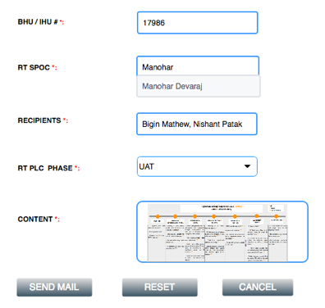

|  |  |  |
| --- | --- | --- |
| **Label Name** | **Field Type** | **Purpose** |
| BHU / IHU # | Alphanumeric Text filed | Input Field |
| RT SPOC | Alphanumeric Text filed | Input Field |
| RECIPIENTS | Email id field | Input Field |
| RT PLC Phase | Drop down list | Input Field  Values :  Kick-Off  Design & Development  IT  UAT  RT  Warranty Phase  P2S Handover |
| CONTENT | Alphanumeric Text filed | Email Content |